Chapter 8, Problem 72.

The switch in Fig. 8.117 has been in position 1 for a long time. At t = 0, it is switched to position 2. Use Pspice to find i(t) for 0 < t < 0.2 s.
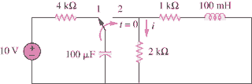

Figure 8.117
For Prob. 8.72.

